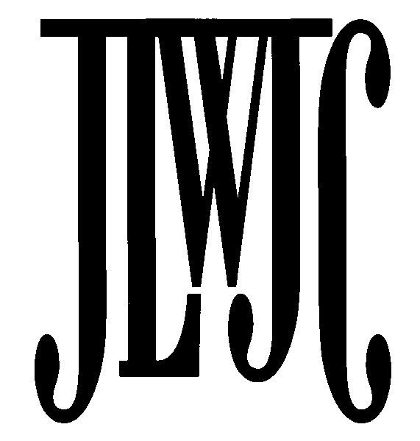

2021 Cotillion Participation Recommendation
For consideration of candidates presented at the Community Ball on Saturday, December 4, 2021
(All Requests for Candidates are Confidential)

Please submit name(s) of High School Juniors or Seniors (Class of 2022 or 2023 graduates) to be considered for participation in the 2021 Community Ball.

PLEASE NOTE THE DEADLINE! The completed form is due MAY 1, 2021.

Please submit to:
Marsha Oyer, JLWJC Cotillion Chair
15506 Cedar Lane, Basehor, KS 66007 816.225.7056
jlwjccotillion@gmail.com

This form must be completed for each proposed Cotillion candidate.

Selected candidates will receive a formal invitation in later spring or summer. Candidates and their parents assume all financial responsibilities and time commitments for the Cotillion. All recommendations for candidates are confidential.

Selection Guidelines

- High School Junior or Senior with achievement(s) in community service, volunteerism, and leadership.
- Family’s contribution to the civic/cultural/commercial enrichment of the JLWJC and Kansas City community.

Proposed Cotillion Candidate Information
(Please print)

Candidate Full Name:
(Last) (First) (Middle)
Candidate Gender (check one): Male □ Female

Home Address: City: State: Zip: Email: __________________________ School: ____________________________________________ Evening Telephone: __________________________ __

Mother’s Full Name: (include title) ______________ Telephone:________________________________________

Home Address: (if different than Candidate) Email: Business: Father’s Full Name: (include title) Telephone:
Home Address: (if different than Candidate)
Email: Business:

2021 Cotillion Participation Recommendation Form Page 2-

Family’ s Community Support and Involvement
Family Community Involvement:

Name of relatives who have participated in the Cotillion and relationship to the Candidate:
Name: Relationship: _____________________________________
Name: Relationship:

Candidate Background-Achievement-Honors:
Please provide your personal evaluation of the candidate. Please include volunteer activities, leadership abilities and/or honors or awards. You may use the back of the sheet or attach information/resume.

Nomination by member of the Junior League of Wyandotte and Johnson Counties:
Please check the applicable statements:
  - I have known the proposed candidate for years.
  - I have known the proposed participant’s family for years.
  - I do not know the proposed candidate – information came from:

Recommendation submitted by: __________ Date: Phone:_________________________________ Email: __________________________________________Provisional____Active____Sustainer____

For questions, please contact Marsha Oyer, 2021 Cotillion Chair,

jlwjccotillion@gmail.com

816.225.7056

