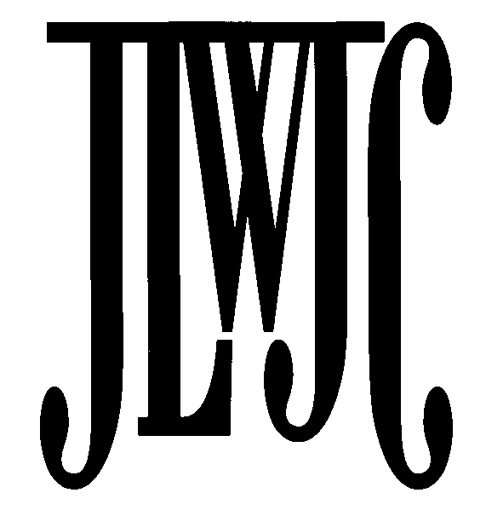

2019 Cotillion Participation Recommendation
For consideration of candidates presented at the Community Ball on Saturday, December 7, 2019
(All Requests for Candidates are Confidential)

Please submit name(s) of High School Juniors or Seniors (Class of 2021 or 2020 graduates) to be considered for participation in the 2019 Community Ball.

PLEASE NOTE THE DEADLINE! The completed form is due MAY 1, 2019.

Please submit to:
Monica Browne, JLWJC Cotillion Co-Chair
21703 West 98th Terrace Lenexa, KS 66220 913.707.5676
jlwjccotillion@gmail.com

This form must be completed for each proposed Cotillion candidate.

Selected candidates will receive a formal invitation in later spring or summer. Candidates and their parents assume all financial responsibilities and time commitments for the Cotillion. All recommendations for candidates are confidential.

Selection Guidelines

- High School Junior or Senior with achievement(s) in community service, volunteerism, and leadership.
- Family’s contribution to the civic/cultural/commercial enrichment of the JLWJC and Kansas City community.

Proposed Cotillion Candidate Information
(Please print)

Candidate Full Name:
(Last) (First) (Middle)
Candidate Gender (check one): Male □ Female □
School __________________________________________________
Home Address: City: State: Zip: Email: School: Evening Telephone:

Mother’s Full Name: (include title)
Telephone:

Home Address: (if different than Candidate) Email: Business: Father’s Full Name: (include title) Telephone:
Home Address: (if different than Candidate)
Email: Business:

-2019 Cotillion Participation Recommendation Form Page 2-

Family’ s Community Support and Involvement
Family Community Involvement:

Name of relatives who have participated in the Cotillion and relationship to the Candidate:
Name: Relationship: _____________________________________
Name: Relationship:

Candidate Background-Achievement-Honors:
Please provide your personal evaluation of the candidate. Check any of the following that apply and provide your comments and/or examples to the right.

Activities/Honors Comments
- Volunteer Activities (please list)
- Leadership Abilities (please list)
- Honors/Awards (please list)
- Other Activities

Nomination by member of the Junior League of Wyandotte and Johnson Counties:
Please check the applicable statements:
  - I have known the proposed candidate for years.
  - I have known the proposed participant’s family for years.
  - I do not know the proposed candidate – information came from:

Recommendation submitted by: __________ Date: Phone:_________________________________ Email: __________________________________________Provisional____Active____Sustainer____

For questions, please contact Monica Browne, 2019 Cotillion Co-Chair,

jlwjccotillion@gmail.com

913.707.5676

